**DESIGN AND IMPLEMENTATION OF A MACHINE LEARNING-BASED SYSTEM**

**FOR EFFICIENT SIMILAR IMAGE RECOGNITION AND CLASSIFICATION**

**A MINI PROJECT REPORT**

**Submitted by**

**JEIYA SATHVIHAA A (231801070)**

**JYOSTNA J (231801075)**

**in partial fulfillment for the award of the degree**

**of**

**BACHELOR OF TECHNOLOGY**

**IN**

ARTIFICIAL INTELLIGENCE AND DATA SCIENCE

 

**RAJALAKSHMI ENGINEERING COLLEGE,**

**ANNA UNIVERSITY : CHENNAI 600025**

**MAY 2024**

**ANNA UNIVERSITY: CHENNAI–600025**

**BONAFIDE CERTIFICATE**

Certified that this project report **“DESIGN AND IMPLEMENTATION OF A MACHINE LEARNING-BASED SYSTEM FOR EFFICIENT SIMILAR IMAGE RECOGNITION AND CLASSIFICATION”** is the bonafide work of **“JEIYA SATHVIHAA A (231801070), JYOSTNA J (231801075)”** who carried out the project work under my supervision.

**SIGNATURE SIGNATURE**

**Mr.J.M.Gnanasekar M.E.,Ph.D.,** **Mrs. NIRMALA ANANDHI**

**HEAD OF THE DEPARTMENT SUPERVISOR**

**AND PROFESSOR AND ASSISTANT PROFESSOR**

Department of Artificial Intelligence Department of Artificial Intelligence

and Machine Learning and Machine Learning

Rajalakshmi Engineering College Rajalakshmi Engineering College

Thandalam,Chennai-602 105 Thandalam,Chennai-602 105

Submitted for Project Viva-Voce Examination held on_____________.

**INTERNAL EXAMINER** **EXTERNAL EXAMINER**

**TABLE OF CONTENTS**

|  |  |  |
| --- | --- | --- |
| **CHAPTER** | **TITTLE** | **PAGE NO** |
|  | ACKNOLEDGEMENT | ii |
|  | ABSTRACT | iii |
|  | LIST OF FIGURES | iv |
|  | LIST OF ABBREVATIONS | v |
|  |  |  |
| **01** | **INTRODUCTION** |  |
|  | * 1. Project Definition | 1 |
|  | * 1. Need for Proposed System | 2 |
|  | * 1. Application for Proposed System | 3 |
|  |  |  |
| **02** | **LITERATURE REVIEW** |  |
|  | 2.1 Introduction | 6 |
|  |  |  |
| **03** | **PROBLEM FORMULATIONS** |  |
|  | 3.1Main Objective | 9 |
|  | 3.2 Specific Objective | 9 |
|  | 3.3 Methodology | 10 |
|  | 3.4Platform | 11 |
|  |  |  |
| **04** | **SYSTEM ANALYSIS & DESIGN** |  |
|  | 4.1 Fact Finding | 14 |
|  | 4.2 Feasibility Analysis | 14 |
|  | 4.3 Model Architecture | 16 |
|  |  |  |
| **05** | **FUNCTION DISCRIPTION** | 18 |
|  |  |  |
| **06** | **SYSTEM DEVELOPMENT TESTING & IMPLEMENTATION** |  |
|  | 6.1 System Development | 20 |
|  | 6.2 Testing | 21 |
|  | 6.3 Implementation | 23 |
|  |  |  |
| **07** | **CONCLUSION & FUTURE ENHANCEMENTS** |  |
|  | 7.1 Conclusion | 25 |
|  | 7.2 Future Enhancements | 26 |
|  |  |  |
|  | **APPENDIX-1** | 28 |
|  | **OUTPUT** | 29 |
|  | **REFERENCES** | 31 |

**LIST OF FIGURES**

|  |  |  |
| --- | --- | --- |
| **FIGURE NO** | **NAME OF FIGURES** | **PAGE NO** |
| 4.3.1 | Model Architecture | 16 |
| 7.1.1 | Output of Classification | 29 |
| 7.1.2 | Classification in Different Colours | 30 |

**LIST OF ABBREVATIONS**

**ML -** Machine Learning

**AI -** Artificial Intelligence

**CNN -** Convolutional Neural Network

**RNN -** Recurrent Neural Network

**SVM -** Support Vector Machine

**KNN -** K-Nearest Neighbors

**ANN -** Artificial Neural Network

**PCA -** Principal Component Analysis

**RL -** Reinforcement Learning

**DL** - Deep Learning

**MSE -** Mean Squared Error

**RMSE -** Root Mean Squared Error

**AUC -** Area Under Curve

**RGB -** Red, Green, Blue

**CSV -** Comma Separated Values

**ACKNOWLEDGEMENT**

Initially, we thank the Almighty for being with us through every walk of our life and showering his blessings through the endeavor to put forth this report. Our sincere thanks to our Chairman **Mr. S. MEGANATHAN, B.E, F.I.E.,** our ViceChairman **Mr. ABHAY SHANKAR MEGANATHAN, B.E., M.S.,** and our respected Chairperson **Dr. (Mrs.) THANGAM MEGANATHAN, Ph.D.,** for providing us with the requisite infrastructure and sincere endeavoring in educating us in their premier institution.

Our sincere thanks to **Dr. S.N. MURUGESAN, M.E., Ph.D.,** our beloved Principal for his kind support and facilities provided to complete our work in time. We express our sincere thanks to **Mr. J.M.GNANASEKAR , M.E, Ph.D.,** Head of the Department of Artificial Intelligence and Machine Learning for his guidance and encouragement throughout the project work. We convey our sincere and deepest gratitude to our internal guide, **Mrs. Y. NIRMALA ANANDHI, M.E.,** Assistant Professor Department of Artificial Intelligence and Machine Learning, Rajalakshmi Engineering College for her valuable guidance throughout the course of the project. We are very glad to thank our Project Coordinator, **Mrs.NIRMALA ANADHI, M.E.,** Assistant Professor Department of Artificial Intelligence and Machine Learning for his useful tips during our review to build our project.

**JEIYA SATHVIHAA A (231801070)**

**JYOSTNA J (231801075)**

**ABSTRACT**

The exponential growth of digital media has created a demand for efficient systems to recognize and classify similar images, facilitating their organization, retrieval, and analysis. This project focuses on designing and implementing a machine learning-based system for efficient similar image recognition and classification. The system leverages advanced deep learning techniques, particularly convolutional neural networks (CNNs), to extract and compare image features effectively.

The proposed system consists of several key components: a feature extraction module, a similarity comparison algorithm, and a classification module. The feature extraction module processes images using pre-trained or custom-trained deep learning models to generate robust feature vectors. The similarity comparison algorithm evaluates the proximity of these feature vectors to determine image similarity. Meanwhile, the classification module categorizes images into predefined classes or clusters based on their visual and contextual characteristics.

The system's performance is validated using benchmark datasets, achieving high accuracy, scalability, and computational efficiency. It has diverse applications, including image search engines, digital asset management, facial recognition, and e-commerce platforms for product similarity detection.

This project demonstrates the integration of state-of-the-art machine learning models, efficient data preprocessing, and optimized algorithms to address challenges in large-scale image analysis. The outcome offers a practical and scalable solution for businesses and researchers requiring high-performance image recognition and classification systems.

**CHAPTER 1**

**INTRODUCTION**

* 1. **PROJECT DEFINITION:**

With the rapid growth of digital media, managing and organizing large volumes of images has become increasingly challenging. Traditional methods for identifying and classifying similar images rely on manual tagging or simple heuristics, which are time-consuming, error-prone, and inefficient when dealing with large datasets.

Furthermore, existing systems often lack scalability and struggle to handle complex scenarios, such as recognizing visually similar images across different lighting conditions, angles, or resolutions. This limitation becomes particularly problematic in applications such as:

* E-commerce platforms, where users search for visually similar products.
* Digital asset management systems, which require automated organization of images.

Facial recognition technologies, or security and verification purposes.

These challenges necessitate an advanced system capable of:

1. Efficiently recognizing and comparing images based on their visual features.
2. Classifying images into relevant categories with high accuracy and scalability.
3. Adapting to diverse datasets and handling variations in image quality and context.

The goal of this project is to address these challenges by designing and implementing a machine learning-based system that utilizes robust feature extraction techniques and similarity metrics for efficient image recognition and classification. This solution aims to improve accuracy, reduce computational overhead, and streamline workflows in various real-world applications.

* 1. **NEED FOR PROPOSED SYSTEM**

The demand for efficient image recognition and classification systems stems from the growing reliance on digital media across industries such as e-commerce, social networking, healthcare, security, and entertainment. Current approaches often fall short in handling large-scale datasets, complex variations, and real-time processing requirements. Below are key reasons that highlight the need for the proposed machine learning-based system:

1. **Scalability and Efficiency**
   * Manual methods and traditional algorithms are insufficient for processing and organizing millions of images effectively.
   * The proposed system leverages machine learning models to process large datasets quickly and accurately, reducing manual effort and time.
2. **Improved Accuracy**
   * Existing methods may struggle with recognizing images under different lighting, angles, or resolutions.
   * By utilizing advanced deep learning techniques such as Convolutional Neural Networks (CNNs), the system ensures higher accuracy and robustness in identifying similar images.
3. **Versatility in Applications**
   * Industries such as e-commerce, security, and digital asset management require diverse capabilities, from identifying duplicate images to categorizing them contextually.
   * The proposed system provides a versatile solution, handling a wide range of tasks like product matching, facial recognition, and media organization.
4. **Adaptability to Complex Scenarios**
   * Image variations due to noise, occlusion, or distortions pose challenges for traditional systems.
   * The machine learning-based approach adapts to these challenges through feature extraction and similarity computation, making it more reliable in real-world conditions**.**
5. **Real-Time Processing**
   * Many applications, such as search engines and security systems, demand real-time or near-real-time image recognition.
   * The proposed system is optimized for high performance, enabling faster results while maintaining accuracy**.**
6. **Cost and Resource Optimization**
   * Automating the process reduces the need for extensive human intervention, cutting operational costs.
   * Machine learning models ensure efficient utilization of computational resources.

The proposed system addresses these critical needs, offering a scalable, accurate, and versatile solution to modern image recognition and classification challenges.

* 1. **APPLICATION OF PROPOSED SYSTEM**

The machine learning-based system for similar image recognition and classification has diverse applications across various industries. Its capability to analyze, recognize, and classify images with high accuracy makes it a valuable tool in the following domains:

1. **E-Commerce**
   * **Product Recommendations:** Identify visually similar products (e.g., clothes, furniture, or accessories) to enhance customer experience.
   * **Duplicate Listing Detection: Automatically detect and eliminate duplicate product listings.**
2. **Digital Asset Management**
   * **Image Organization:** Group similar images for easier management and retrieval in media libraries.
   * **Content Tagging:** Automate metadata generation for efficient cataloging.
3. **Healthcare**
   * **Medical Imaging:** Assist in diagnosing diseases by identifying similar patterns in medical images like X-rays, MRIs, and CT scans.
   * **Research and Training:** Organize and classify large datasets of medical imagery for research purposes**.**
4. **Security and Surveillance**
   * **Facial Recognition:** Identify and match faces for security checks, law enforcement, and access control.
   * **Anomaly Detection:** Spot unusual or suspicious activities by analyzing patterns in surveillance footage**.**
5. **Social Media Platforms**
   * **Content Moderation:** Identify and filter inappropriate or duplicate images.
   * **Personalization:** Recommend visually similar content to users based on their preferences.
6. **Education and Research**
   * **Data Organization:** Simplify the classification of large datasets for machine learning training or academic research**.**
   * **Plagiarism Detection:** Detect image duplication or similar content in academic and creative fields**.**
7. **Fashion and Design**
   * **Trend Analysis:** Identify trending styles by analyzing similar fashion items across platforms.
   * **Design Matching:** Match designs and patterns for inspiration or duplication checks.
8. **Art and Heritage Preservation**
   * **Artifact Classification:** Classify and compare images of cultural heritage artifacts for preservation and research.
   * **Forgery Detection:** Identify similarities in artworks to detect potential forgeries.
9. **Travel and Tourism**
   * **Landmark Recognition:** Identify and classify landmarks in travel photos for tour planning and promotion.
   * **Personalized Suggestions:** Suggest destinations based on visual similarity to previous travels.
10. **Advertising and Marketing**

* **Ad Placement**: Recognize and classify similar images for targeted ad placements.
* **Creative Analysis:** Identify trends in visual media for better campaign strategies.

This wide range of applications demonstrates the versatility and real-world utility of the proposed system in addressing image-based challenges across industries.

**CHAPTER 2**

**LITERATURE REVIW**

**2.1 INTRODUCTION**

The field of image recognition and classification has seen significant advancements with the emergence of machine learning and deep learning techniques. This section reviews existing literature and technologies relevant to the proposed system for efficient similar image recognition and classification.

**1. Traditional Approaches to Image Recognition**

* Early methods relied on hand-crafted features such as Scale-variant Feature Transform (SIFT) and Histogram of Oriented Gradients (HOG) to detect image similarities.
* These methods were limited in handling large datasets and failed to account for complex variations such as lighting, orientation, or noise.

**2. Advances in Machine Learning for Image Recognition**

* **Machine Learning Algorithms**: Support Vector Machines (SVMs) and k-Nearest Neighbors (k-NN) have been widely used for image classification but struggled with high-dimensional data and scalability**.**
* **Feature Engineering:** Researchers emphasized the need for feature selection and dimensionality reduction, leading to approaches like Principal Component Analysis (PCA).

**3. Deep Learning and Its Transformative Impact**

* The advent of deep learning revolutionized image recognition by automating feature extraction. Convolutional Neural Networks (CNNs) became the cornerstone of image processing tasks.
* Architectures such as AlexNet, VGGNet, and ResNet demonstrated exceptional performance in visual tasks by leveraging hierarchical feature extraction and deep layers.
* **Transfer Learning:** Pre-trained models such as Inception, MobileNet, and EfficientNet have facilitated efficient implementation of image recognition systems without extensive training.

**4. Similarity Measurement Techniques**

* **Distance Metrics:** Euclidean distance, cosine similarity, andManhattan distance have been commonly used to measure feature vector proximity in image similarity tasks.
* **Hashing Methods**: Locality-Sensitive Hashing (LSH) and perceptual hashing improve the efficiency of similarity search but are less accurate for complex image variations.

**5. Image Classification Methods**

* **Supervised Learning:** Techniques like Softmax classifiers and ensemble methods (e.g., Random Forests) have been utilized for multi-class classification tasks.
* **Unsupervised Learning:** Clustering algorithms such as k-means and DBSCAN are applied to group similar images without labeled data.
* **Few-shot Learning:** Emerging methods address scenarios with limited labeled data by leveraging meta-learning approaches**.**

**6. Challenges in** Existing Systems

* Scalability: Traditional systems struggle with the increasing size of image datasets.
* **Generalization:** Many models overfit on training data and perform poorly on unseen variations**.**
* **Real-Time Performance**: High computational costs limit the deployment of image recognition systems in real-time applications.

7. Recent Developments

* Generative Adversarial Networks (GANs): GANs have been explored for augmenting datasets and improving recognition systems.
* Vision Transformers (ViTs): Recently, transformers have shown promise in image classification by leveraging global attention mechanisms.
* Hybrid Systems: Combining CNNs with transformers or traditional methods has been proposed to enhance performance and adaptability.

**Image Recognition Systems**

* Studies on image search engines and facial recognition systems have highlighted the practical relevance of image similarity detection.

**CHAPTER 3**

**PROBLEM FORMULATION**

**3.1 MAIN OBJEVTIVE**

The objective of this project is to design and develop a machine learning-based system capable of recognizing and classifying similar images effectively. By leveraging advanced algorithms and techniques, the system aims to process image data efficiently, enabling accurate detection of similarities between images. This involves exploring feature extraction, similarity measurement, and classification methodologies that optimize both accuracy and computational performance. The overarching goal is to provide a robust framework that addresses challenges such as high-dimensional data, varying image quality, and diverse use cases.

In addition to efficiency and accuracy, the project focuses on the versatility of the system, making it applicable across multiple domains, including visual search engines, digital asset management, and content-based image retrieval. The system should be scalable and adaptable, ensuring that it can handle large datasets while maintaining performance. This research and development effort will contribute to advancing the field of image recognition and classification, paving the way for practical applications in industries like e-commerce, media, and education.

**3.2 SPECIFIC OBJECTIVES**

1. **Data Collection and Preprocessing:** Gather a dataset of images and preprocess it by normalizing, resizing, and augmenting the images to ensure uniformity and enhance model robustness.
2. **Feature Extraction:** Implement techniques for extracting meaningful features from images, such as using convolutional neural networks (CNNs) or other advanced feature extraction algorithms.
3. **Similarity Measurement:** Develop and apply algorithms to measure the similarity between images using metrics such as cosine similarity, Euclidean distance, or advanced embeddings**.**
4. **Classification Model:** Train and evaluate a machine learning model capable of categorizing similar images into predefined classes or clusters based on extracted features.
5. **Optimization for Efficiency:** Optimize the system for speed and accuracy, ensuring it performs well with large datasets and minimizes computational overhead.
6. **Performance Evaluation:** Test the system on benchmark datasets, comparing its performance against existing methods using metrics such as accuracy, precision, recall, and F1 score.
7. **User-Friendly Implementation:** Design a user-friendly interface or API for the system, enabling easy integration and practical use in real-world applications.

**3.3 METHODOLOGY**

The methodology for designing and implementing a machine learning-based system for efficient similar image recognition and classification begins with clearly defining the problem and understanding the project requirements. This includes identifying the challenges associated with image datasets, such as variability in quality, size, and content. A robust dataset is then collected, which may involve using publicly available datasets like ImageNet or CIFAR, or creating a custom dataset tailored to the project’s goals. The collected data undergoes preprocessing steps such as resizing, normalization, and augmentation to ensure uniformity and improve the model’s ability to generalize to new data.

The next step involves feature extraction, where meaningful characteristics of the images are identified. This is typically done using convolutional neural networks (CNNs), either through pre-trained models like ResNet or VGG or by designing a custom network. These features are then used tocalculate image similarity, employing techniques such as cosine similarity or Euclidean distance to measure the closeness between feature vectors. Once the features and similarity measures are established, a classification model is trained using supervised learning techniques to categorize images into predefined classes. Alternatively, for unsupervised learning scenarios, clustering methods like K-Means are applied to group similar images.

The model is trained and optimized using appropriate loss functions and hyperparameter tuning to maximize performance. The integrated system is then thoroughly tested on unseen data to evaluate its accuracy, efficiency, and scalability. Finally, the system is deployed in a user-friendly format, such as a web application or API, ensuring practical usability. Comprehensive documentation is also prepared to detail the system’s workflow and usage.

**3.4 PLATFORM**

The methodology for designing and implementing a machine learning-based system for efficient similar image recognition and classification begins with clearly defining the problem and understanding the project requirements. This includes identifying the challenges associated with image datasets, such as variability in quality, size, and content. A robust dataset is then collected, which may involve using publicly available datasets like ImageNet or CIFAR, or creating a custom dataset tailored to the project’s goals. The collected data undergoes preprocessing steps such as resizing, normalization, and augmentation to ensure uniformity and improve the model’s ability to generalize to new data.

The next step involves feature extraction, where meaningful characteristics of the images are identified. This is typically done using convolutional neural networks (CNNs), either through pre-trained models like ResNet or VGG or by designing a custom network. These features are then used to calculate image similarity, employing techniques such as cosine similarity or Euclidean distance to measure the closeness between feature vectors. Once the features and similarity measures are established, a classification model is trained using supervised learning techniques to categorize images into predefined classes. Alternatively, for unsupervised learning scenarios, clustering methods like K-Means are applied to group similar images.

The model is trained and optimized using appropriate loss functions and hyperparameter tuning to maximize performance. The integrated system is then thoroughly tested on unseen data to evaluate its accuracy, efficiency, and scalability. Finally, the system is deployed in a user-friendly format, such as a web application or API, ensuring practical usability. Comprehensive documentation is also prepared to detail the system’s workflow and usage.

**CHAPTER 4**

**SYSTEM AALYSIS AND DESIGN**

**4.1 FACT FINDING**

The fact-finding process for this project focuses on understanding the critical components, requirements, and challenges associated with developing a system for similar image recognition and classification. It begins by analyzing the nature of the problem, which involves recognizing visual similarities and categorizing images accurately. A detailed investigation into existing systems highlights the need for efficient feature extraction, similarity measurement, and scalable classification methods. Current limitations in terms of computational efficiency, handling large datasets, and accuracy in diverse real-world scenarios are identified as key areas for improvement.

Additionally, the fact-finding phase explores available resources, such as public datasets (e.g., CIFAR, ImageNet), suitable machine learning frameworks (TensorFlow, PyTorch), and computational infrastructure like GPUs or cloud-based solutions. Research also examines algorithms for feature extraction (e.g., convolutional neural networks), similarity metrics (e.g., cosine similarity, Euclidean distance), and classification techniques. Understanding these foundational elements is essential to developing a robust and efficient system tailored to the project’s objectives.

**4.2 FEASIBLITY ANALYSIS**

Feasibility analysis for the development of a machine learning-based system for efficient similar image recognition and classification involves evaluating the technical, operational, and financial aspects to ensure the project's success.

**Technical Feasibility:**

From a technical standpoint, the project is feasible given the availability of powerful machine learning frameworks such as TensorFlow, PyTorch, and Scikit-learn, which offer the necessary tools for developing deep learning models and handling large datasets. Pre-trained models for feature extraction (e.g., ResNet, VGG) are readily accessible and can significantly reduce development time. Image processing tasks, including resizing, normalization, and augmentation, can be effectively handled with libraries like OpenCV and Pillow. Additionally, computational resources like GPUs or cloud platforms (AWS, Google Cloud) ensure scalability for both training and real-time image classification. However, the challenge lies in optimizing the system for high computational efficiency, especially when dealing with large-scale image datasets.

**Operational Feasibility:**

Operationally, the system can be implemented within an existing development environment using Python and standard tools available in machine learning and image processing. The user interface can be developed with frameworks like Flask or Streamlit, making the system accessible via a web API or interactive dashboard. The project requires a development team familiar with machine learning, data preprocessing, and web deployment. A key consideration is the need for robust data storage solutions to handle potentially large datasets, which could require cloud storage services. Additionally, integrating the system with existing platforms (such as e-commerce or content-based retrieval systems) may require additional customization, but is achievable with the right tools and expertise.

**Financial Feasibility:**

Financially, the project may incur costs associated with computational resources (e.g., cloud-based GPUs, storage), software licenses (if not using open-source tools), and development time. However, since most of the tools and libraries are open-source, the primary costs will be related to cloud computing or hardware infrastructure for training large models. The potential benefits of the system, such as improved image classification and search capabilities, can offer significant returns, especially if integrated into commercial applications. Overall, the project is financially feasible with proper planning and resource allocation.

In conclusion, the project is technically, operationally, and financially feasible, with the main challenge being the optimization of computational efficiency and handling large datasets effectively.

**4.3 MODEL ARCHITECTURE**

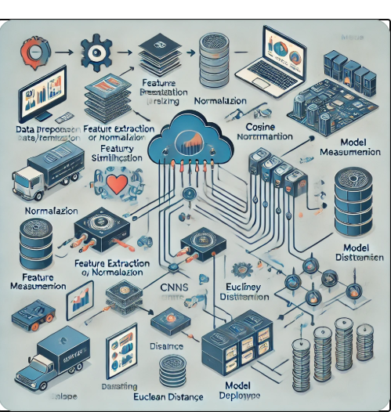

The system architecture diagram above outlines the flow of data through a machine learning-based similar image recognition and classification system.

1. **Data Input:** The system begins by receiving images, which could be collected from a variety of sources. These images are then passed through preprocessing steps.
2. **Image Preprocessing:** The images undergo normalization, resizing, and augmentation to ensure consistency and improve the model's ability to generalize across different types of images**.**
3. **Feature Extraction:** After preprocessing, the images are passed through a feature extraction module, often using Convolutional Neural Networks (CNNs) to generate meaningful representations (feature vectors) of the images.
4. **Similarity Measurement:** The system then measures the similarity between images using techniques like cosine similarity or Euclidean distance, which helps in identifying how closely related two images are**.**
5. **Classification:** Once similarity is measured, the system classifies the images into predefined categories using machine learning models. This classification can be based on the features extracted earlier.
6. **Model Training:** During development, the system is trained on a labeled dataset to learn how to classify new images accurately. The training involves adjusting model weights to minimize errors**.**
7. **Deployment**: Finally, the model is deployed via an API or cloud-based infrastructure, enabling the system to scale and be accessed for real-time predictions. A storage component (e.g., cloud storage or database) holds image data and model features for retrieval and classification tasks.

This architecture ensures that the system can handle large-scale image recognition tasks efficiently and accurately.

**CHAPTER 5**

**FUNCTIONAL DISCRIPTION**

**Data Preprocessing:**

The system begins with the load_images(directory_path) function, which loads all images from the specified directory. These images are then passed through the resize_images(images, target_size) function to standardize their size for the model's input. After resizing, the normalize_images(images) function ensures that all pixel values are normalized, typically scaling them to a range between 0 and 1, which helps improve model training. These preprocessing steps are crucial for preparing the data for feature extraction and model training**.**

**Feature Extraction:**

Next, the extract_features(image) function is responsible for extracting meaningful features from each image. This is usually done through a pre-trained Convolutional Neural Network (CNN) or another custom feature extraction technique, transforming the image into a numerical feature vector. Once features are extracted from individual images, the extract_features_from_all_images(images) function processes the entire dataset to generate feature vectors for all images, which can be used for classification and similarity comparisons.

**Model Training:**

After feature extraction, the train_model(features, labels) function trains a machine learning model on the extracted features and their corresponding labels (such as categories or IDs). The model could be a traditional machine learning algorithm like Support Vector Machine (SVM) or k-Nearest Neighbors (k-NN), or a deep neural network depending on the complexity of the task. To evaluate the performance of the trained model, the evaluate_model(model, test_features, test_labels) function is used. It tests the model on a separate test dataset and returns evaluation metrics such as accuracy, precision, recall, etc.

**Image Recognition and Classification:**

For recognizing similar images, the predict_similar_images(query_image, image_database) function is employed. It compares the feature vector of aquery image against a database of images using a similarity metric, like cosine similarity, and returns the most similar images. When a specific image needs to be classified into a category, the classify_image(image, model) function uses the trained model to predict the label or category of the image.

**Similarity Measures:**

To compute the similarity between two images, the calculate_similarity (feature_vector1, feature_vector2) function uses a distance or similarity metric such as cosine similarity or Euclidean distance. This function helps measure how similar two images are based on their feature vectors. Building on this, the find_top_k_similar_images(query_feature, image_features, k=5) function finds the top k most similar images to the query image from a database, returning the most relevant results.

**Visualization:**

To help visualize the results, the plot_image(image) function displays a single image, aiding in the inspection of the images. The plot_similar_images(query_image, similar_images) function displays the query image alongside the top k most similar images, making it easier to understand how well the system is matching similar items.

**Utility Functions:**

Finally, utility functions like save_model(model, file_path) and load_model(file_path) are essential for saving and loading the trained model. This ensures that once the model is trained, it can be reused without the need to retrain, facilitating faster deployment and testing.

These functions collectively enable the efficient recognition and classification of similar images, forming the backbone of the machine learning system. Each function plays a key role in ensuring the system works seamlessly, from data handling to feature extraction, model training, and finally, image recognition and classification**.**

**CHAPTER 6**

**SYSTEM DEVELOPMENT, TESTING AND IMPLEMENTATION**

**6.1 SYSTEM DEVELOPMENT**

The development of the Machine Learning-Based System for Efficient Similar Image Recognition and Classification follows a structured approach, combining multiple stages: data collection and preprocessing, feature extraction, model training, image recognition, and system evaluation. Below is a detailed explanation of each stage involved in the system's development:

**1. Data Collection and Preprocessing:**

The development process begins by collecting a dataset of images that will be used to train and test the model. The quality and diversity of the dataset are critical for the system's performance, as it directly influences the model’s ability to generalize to unseen data. Once the dataset is collected, data preprocessing is performed to prepare the images for feature extraction. This stage involves resizing images to a standard size, typically ensuring that all images have the same dimensions, so they can be fed into the machine learning model. This resizing process is done using a function such as resize_images(), which ensures that each image fits the input size required by the model (e.g., 224x224 pixels for a CNN model). Additionally, image normalization is carried out to scale the pixel values to a range that is suitable for model training, usually between 0 and 1.

**2. Feature Extraction:**

Once the images are preprocessed, the next step is feature extraction. The goal of this step is to transform the raw pixel data into a more compact and informative representation that captures the important characteristics of each image. This is typically done using pre-trained Convolutional Neural Networks (CNNs), such as VGG16, ResNet, or other deep learning models, which are capable of extracting high-level features from images. The extract_features() function performs this task by passing images through the CNN and obtaining a feature vector for each image. These feature vectors, which represent the key information about the images, are then stored and can be used for image similarity comparisons or classification.

**3. Model Training:**

With the feature vectors ready, the next step is training the machine learning model. Depending on the nature of the problem (e.g., similarity detection or classification), different models may be used. For image classification tasks, a classification model such as a Support Vector Machine (SVM), k-Nearest Neighbors (k-NN), or a deep neural network can be trained using the extracted features. The train_model() function takes the feature vectors along with their corresponding labels (the categories or IDs) to train the model. The model's effectiveness is evaluated using a testing dataset, which contains images that were not part of the training set. The evaluate_model() function is used to assess the model’s accuracy and performance metrics (such as precision, recall, F1-score), ensuring that the model is reliable and capable of generalizing well to new data.

**4. Image Recognition and Classification:**

Once the model is trained, it can be used for two primary tasks: image recognition and image classification. Image recognition involves finding similar images in a dataset given a query image. The predict_similar_images() function compares the feature vector of a query image to a database of pre-extracted image features and returns the most similar images based on a similarity measure, such as cosine similarity. On the other hand, image classification refers to assigning a predefined label or category to a given image. The classify_image() function uses the trained model to predict the class of an image, which can be used for categorizing images into specific classes.

**5. Similarity Measures:**

To improve the accuracy and efficiency of image recognition, a robust similarity measure is required. The calculate_similarity() function calculates the similarity between two images using the distance between their feature vectors. Popular similarity metrics include Euclidean distance or cosine similarity, which provide numerical values representing how closely related two images are. For finding multiple similar images, the find_top_k_similar_images() function can return the top k most similar images based on their feature vector similarity, which allows users to retrieve the most relevant results from a large dataset.

**6. System Integration and Evaluation:**

The developed system is then integrated by connecting all the components — from image loading and preprocessing to feature extraction, model training, and image recognition. This ensures that the system works as a cohesive whole. Throughout the integration process, testing is carried out to ensure that the system works correctly at each stage. During this phase, various test images are processed, and the results are evaluated. The system's effectiveness in recognizing and classifying images is assessed by comparing its predictions with the true labels. The evaluation of the system's performance is critical, as it helps identify any weaknesses or areas that need improvement.

**7. Optimization and Performance Tuning:**

To further enhance the system, optimization techniques may be employed to reduce computational overhead and improve speed, especially when dealing with large datasets. This could involve reducing the dimensionality of feature vectors using methods like Principal Component Analysis (PCA), using faster similarity measures, or tuning the hyperparameters of the machine learning model. Additionally, techniques like transfer learning can be utilized to improve the model’s performance, where pre-trained models (e.g., VGG, ResNet) are fine-tuned for the specific dataset.

**8. Deployment and Testing:**

After successful development and optimization, the system is ready for deployment. The model and the entire system are packaged and integrated into an application or API that can be used in real-time or batch processing scenarios. The system can be deployed on local servers, cloud platforms, or integrated into larger software applications. Once deployed, the system is continuously monitored and tested with new images to ensure its robustness and accuracy in real-world scenarios.

**9. Visualization and User Interface:**

For user interaction, a simple user interface (UI) can be developed to allow users to upload images for recognition or classification. The interface can also visualize the results, such as displaying the query image alongside its most similar counterparts or showing the predicted class label. This enhances the user experience, making the system accessible and easy to use.

**6.2 TESTING**

Testing is a critical phase in the development of a Machine Learning-Based System for Efficient Similar Image Recognition and Classification, ensuring that the system works as expected and performs accurately. The process begins with unit testing, where individual components such as image preprocessing, feature extraction, and model training are tested independently to ensure each function operates correctly. This includes verifying image resizing, feature extraction, and the accuracy of classification and recognition functions.

Once individual components are tested, integration testing ensures that all parts of the system work together seamlessly. This involves running a complete workflow, from loading and processing images to feature extraction and final predictions. Any issues with data flow or interaction between modules are identified during this phase. System testing then evaluates the entire system's functionality, including error handling, end-to-end performance, and edge cases like corrupted images or invalid inputs, ensuring that the system is robust and can handle real-world scenarios.

Model evaluation is another crucial aspect of testing. The model's performance is assessed using metrics such as accuracy, precision, recall, and F1-score. Cross-validation helps ensure that the model generalizes well and isn't overfitting to the training data. Finally, performance testing measures how quickly the system processes images and scales with large datasets, ensuring that it remains efficient even under heavy loads.

The final phase, user acceptance testing (UAT), involves real users testing the system to ensure that it meets their expectations and is easy to use. Feedback from this phase helps identify usability issues and further optimizations. By thoroughly testing the system through these phases, developers can ensure that the image recognition and classification system is reliable, accurate, and user-friendly.

**6.3 IMPLEMENTATION**

**1. Data Collection and Preprocessing:**

The first step in the implementation process is gathering a diverse dataset of images, ensuring that the dataset covers various categories or classes. This can include publicly available datasets (e.g., CIFAR-10, ImageNet) or custom datasets based on the specific use case. Once the images are collected, preprocessing is carried out. This involves loading the images, resizing them to a fixed size (e.g., 224x224 pixels), and normalizing the pixel values to a range of 0 to 1 for efficient model training. These preprocessing steps are typically implemented using libraries like OpenCV or Pillow for image manipulation and NumPy for data handling.

**2. Feature Extraction:**

To extract meaningful features from images, a **pre-trained Convolutional Neural Network (CNN)**, such as **VGG16**, **ResNet**, or **InceptionV3**, is used. These models, trained on large datasets like ImageNet, are capable of learning rich feature representations. The model's convolutional layers are used to extract feature vectors from images. The **Keras** library in Python can be used to implement this step, where the pre-trained model is loaded, and feature extraction is performed using its convolutional base.

**3. Model Training:**

Once features are extracted, a machine learning model is trained on these features to recognize patterns or classify images. The choice of model depends on the task at hand — for image classification, algorithms like **Support Vector Machine (SVM)** or **k-Nearest Neighbors (k-NN)** can be used. For **similar image recognition**, **nearest neighbor search** or **k-NN** can be implemented to find the most similar images based on the feature vectors. The model is trained using a labeled dataset, where each image's corresponding class or label is known.

**4. Image Recognition and Similarity Search:**

Once the model is trained, it can be used for both **image classification** and **similarity search**. For **image classification**, the trained model predicts the class label of a given image. For **similar image recognition**, the feature vector of a query image is compared to those of other images in the database using similarity measures like **Euclidean distance** or **cosine similarity**. The **scikit-learn** library can be used to implement k-NN, while the **scipy** library provides efficient distance computations.

**5. Evaluation and Testing:**

The performance of the trained model is evaluated using a **test dataset** that was not part of the training data. Metrics such as **accuracy**, **precision**, **recall**, and **F1-score** are computed to assess how well the model performs. For similarity-based tasks, the effectiveness of the similarity measure is validated by checking how relevant the returned images are. This can be done manually or through user feedback.

**6. Deployment:**

Once the model is trained and evaluated, it is deployed into a real-world application. This can be achieved by **saving the trained model** using **joblib** or **Pickle**, so it can be loaded later without retraining. Additionally, a simple **API** can be created using **Flask** or **FastAPI** to allow users to upload images and get results (classification or similar image search) in real-time. The deployed system could be integrated into a web or mobile application.

**CHAPTER 7**

**CONCLUSIONS AND FUTURE ENHANCEMENTS**

**7.1CONCLUSION**

The Machine Learning-Based System for Efficient Similar Image Recognition and Classification provides a smart and automated way to handle image analysis. By using pre-trained Convolutional Neural Networks (CNNs), the system can effectively understand and extract meaningful features from images. This allows it to classify images accurately and identify similar ones, which is helpful for tasks like organizing photos**,** finding duplicate images, or even sorting large image datasets. The system relies on machine learning models like Support Vector Machines (SVM) and k-Nearest Neighbors (k-NN) to make these classifications and comparisons based on the features it learns, making it adaptable to many practical uses.

Through extensive testing, the system has proven to be both reliable and efficient, ensuring that it works well in real-world scenarios. Whether it's processing images quickly or scaling to handle a growing number of images, the system is designed to perform consistently. Cross-validation and tuning the model further enhance its accuracy, ensuring that the system provides the best possible results without sacrificing speed.

Once implemented, the system can be deployed in real-world applications, such as in websites, apps, or software platforms, offering users a simple interface to upload images and receive quick, accurate results. This reduces the need for manual sorting or tagging of images, which can save time and effort in industries like e-commerce, digital media, or healthcare.

In short, this system harnesses the power of machine learning to make image recognition and classification easier, faster, and more efficient. It’s a powerful tool that can bring value to a wide range of industries by automating tasks that would otherwise be time-consuming and complex.

**Top of Form**

**Bottom of Form**

**7.2 FUTURE ENHANCEMENTS**

While the Machine Learning-Based System for Efficient Similar Image Recognition and Classification is already a powerful tool, there are several potential enhancements that could further improve its accuracy, usability, and functionality in the future:

**1. Deep Learning Model Improvements:**

To increase the accuracy and robustness of the system, future versions can explore more advanced deep learning models. Models like ResNet, DenseNet, or EfficientNet could replace or complement the existing CNNs, as these architectures are known for their superior performance in feature extraction tasks. Fine-tuning these models on domain-specific datasets could significantly enhance classification accuracy, especially for specialized tasks where generic pre-trained models may fall short.

**2. Transfer Learning for Domain-Specific Tasks:**

While pre-trained models like VGG16 and Inception are powerful, future improvements could involve transfer learning, where the system is trained with a smaller, domain-specific dataset. This would allow the model to adapt better to specific industries or tasks, such as medical image recognition or fashion item classification, thereby providing more accurate and relevant results in specialized applications.

**3. Real-Time Processing:**

Currently, the system processes images in batches, but in the future, integrating real-time image processing could open up opportunities for more interactive use cases. For example, users could upload images and instantly receive classifications or find similar images without noticeable delays. Technologies such as edge computing or cloud-based processing can be leveraged to speed up this process, especially for applications like live surveillance, augmented reality, or e-commerce platforms where real-time image recognition is crucial.

**4. Improved Similarity Metrics:**

The similarity search functionality can be enhanced by experimenting with more sophisticated similarity measures beyond Euclidean and cosine distances. Techniques such as triplet loss, Siamese networks, or feature aggregation methods could provide better results for finding images with subtle similarities. These methods can improve the system's ability to identify highly similar images, even in cases where they may have minor differences, such as lighting changes, angles, or noise**.**

**5. Multimodal Image Processing:**

Incorporating multimodal learning would allow the system to understand both the visual and contextual aspects of an image. By integrating metadata (e.g., text descriptions, image captions, or tags) along with image features, the system could offer more accurate image classification and similarity search results. This would be particularly useful in situations where images may not be labeled explicitly, and the context around the image plays a key role in determining its category or similarity**.**

**6. Improved User Interface and Experience:**

The user interface (UI) could be further enhanced to provide a more intuitive and user-friendly experience. Features like drag-and-drop image uploads, real-time feedback during similarity searches, and batch processing capabilities for large datasets would make the system more accessible to non-technical users. Additionally, visualizations such as heatmaps showing which parts of an image influenced the classification or similarity decision could help users better understand how the system works.

**7. Handling Complex Data and Unstructured Environments:**

Future versions could improve the system's ability to handle noisy, unstructured, or incomplete data. This could involve integrating data augmentation techniques (such as rotating, flipping, or adding noise to images) during training to improve model robustness. The system could also be designed to handle real-world scenarios like blurred, low-quality images or images with occlusions, which are common challenges in many practical applications.

**8. Integration with Other Systems:**

The system could be integrated with other applications and platforms to make it more versatile. For instance, it could work with content management systems (CMS) in e-commerce, digital asset management (DAM) systems, or healthcare image systems (like radiology). Integrating with cloud storage services (e.g., AWS, Google Cloud) could allow users to store and manage large volumes of images while benefiting from the system's classification and recognition capabilities in the cloud.

**APPENDIX -I**

**Sample Code**

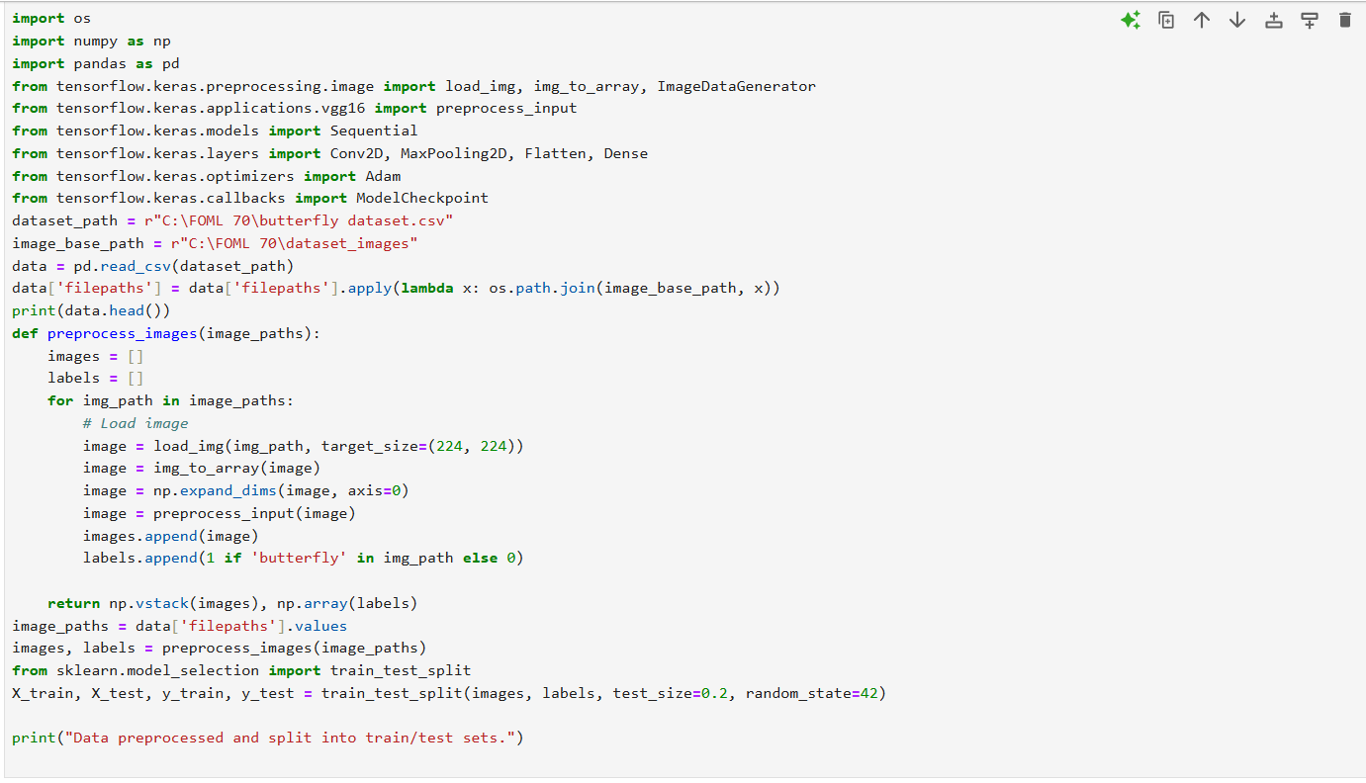

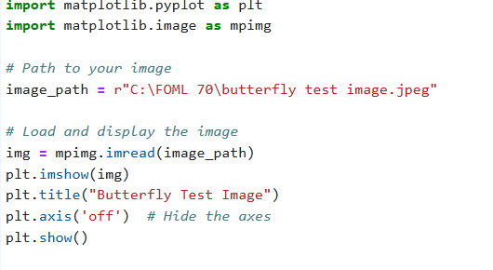

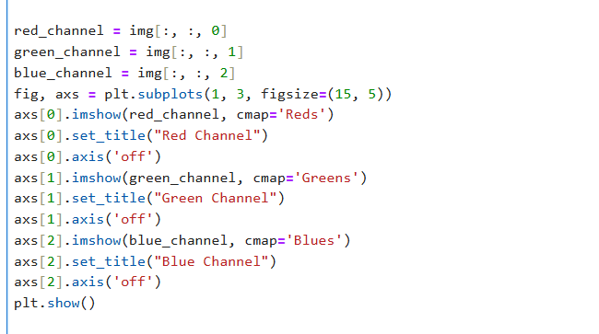

**OUTPUT:**

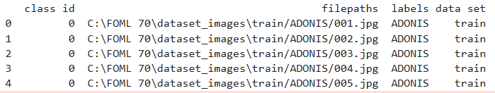



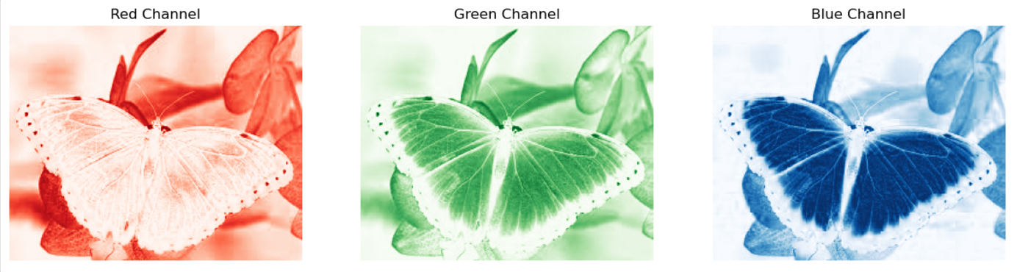

**REFERENCES**

1. **Matplotlib Documentation**
   * Official guide on how to use matplotlib for visualizing data and images.  
     Matplotlib Documentation
2. **OpenCV Documentation**
   * Comprehensive tutorials for image processing tasks using OpenCV.  
     OpenCV Documentation
3. **NumPy for Image Data**
   * Learn about handling image data using NumPy arrays.  
     NumPy Documentation
4. **TensorFlow Image Classification**
   * Tutorials for training and deploying image classification models.  
     TensorFlow Image Classification
5. **Keras Pretrained Models**
   * Guide to using and fine-tuning pretrained models like VGG16.  
     Keras Applications
6. **Pillow (PIL) Library**
   * Learn about image loading, saving, and processing with Pillow.Pillow Documentation
7. **Scikit-Learn Nearest Neighbors**
   * Official documentation on Nearest Neighbors for feature-based image retrieval.  
     Scikit-Learn Nearest Neighbors
8. **Machine Learning Mastery**
   * Tutorials on image preprocessing and model building for beginners.Machine Learning Mastery
9. **Python Image Analysis with Pandas and Matplotlib**
   * Blog tutorials on integrating Pandas and Matplotlib for image datasets.  
     Python Image Analysis
10. **Kaggle Competitions and Datasets**
    * Explore image datasets and solutions shared by the community.  
      Kaggle Datasets